**PIZZA SALES SQL QUERIES**

A.KPI’s

***1. Total Revenue***

SELECT

ROUND(SUM(total_price), 3) AS total_revenue FROM pizza_sales;

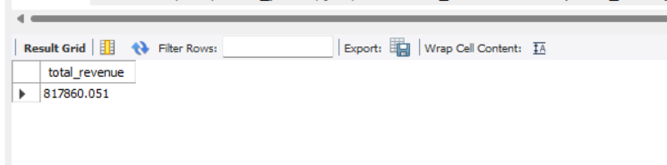

***2. Average Spent Per Order/ Average Order Value***

select Round(SUM(total_price) / count(Distinct order_id),4) as Average_Spent

from pizza_sales;

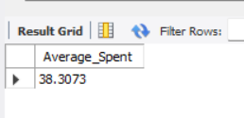

***3. Total Pizzas Sold***

SELECT SUM(quantity) as Total_pizzas_sold

from pizza_sales;

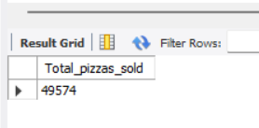

***4. Total Orders Placed***

SELECT COUNT(distinct order_id) as Total_orders

from pizza_sales;

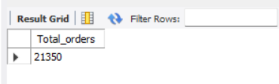

***5. Average Pizzas per Order***

SELECT

(Round( SUM(quantity) / count(DISTINCT order_id),5) ) as Average_Pizza_ordered

from pizza_sales;

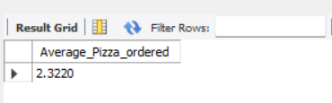

***6. Daily Basis Orders / Daily Trends***

SELECT

DAYNAME(order_date) AS Order_day,

COUNT(DISTINCT order_id) AS Total_order

FROM pizza_sales

GROUP BY Order_day ORDER BY Total_order DESC;

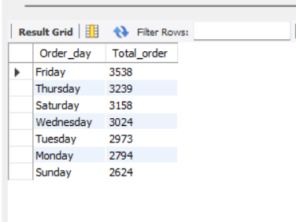

***7. Hourly Trend***

SELECT

EXTRACT(HOUR FROM order_time) as Order_hours ,

COUNT(DISTINCT order_id) AS Total_order

FROM

pizza_sales

GROUP BY Order_hours ORDER BY Total_order DESC;

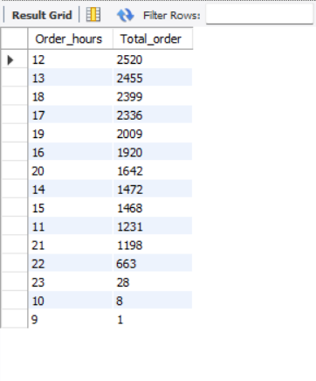

***8. Category Wise Sales Percentage Contribution***

SELECT pizza_category ,sum(total_price) as Total_sales , round(sum(total_price) * 100 / (select sum(total_price) from pizza_sales),3) as percentage_of_sales

from pizza_sales

group by pizza_category;

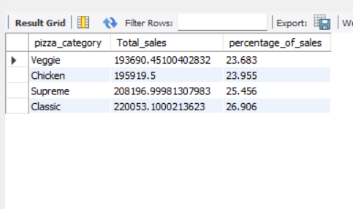

***9. Size wise Sales Percentage Contribution***

SELECT pizza_size , sum(total_price) as total_sales ,round(sum(total_price) * 100 / (select sum(total_price) from pizza_sales),3) as percentage_of_sales

from pizza_sales

group by pizza_size order by percentage_of_sales desc ;

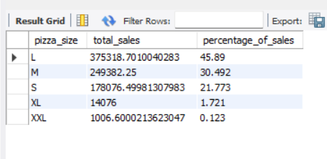

***10. Category wise total pizzas sold***

select pizza_category , sum(quantity) as total_sales from pizza_sales

group by pizza_category order by total_sales desc ;

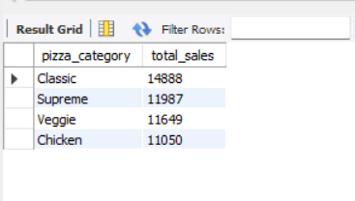

***11. Top 5 Best selling pizzas***

select pizza_name, sum(quantity) as Total_pizzas_sold from pizza_sales

group by pizza_name order by sum(quantity) desc limit 5;

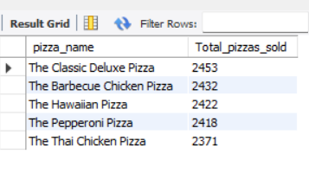

***12. Top 5 least Selling Pizzas***

SELECT

pizza_name, SUM(quantity) AS Total_pizzas_sold

FROM pizza_sales

GROUP BY pizza_name ORDER BY SUM(quantity)

limit 5 ;

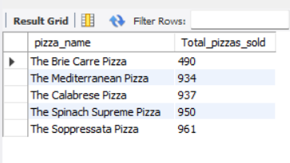

***NOTE***

If you want to apply the Month, Quarter, Week filters to the above queries you can use WHERE clause. Follow some of below examples

SELECT DAYNAME(DW, order_date) AS order_day, COUNT(DISTINCT order_id) AS total_orders

FROM pizza_sales

WHERE MONTH(order_date) = 1

GROUP BY DAYNAME(order_date)

*\*Here MONTH(order_date) = 1 indicates that the output is for the month of January. MONTH(order_date) = 4 indicates output for Month of April.*

SELECT DAYNAME( order_date) AS order_day, COUNT(DISTINCT order_id) AS total_orders

FROM pizza_sales

WHERE EXTRACT(QUARTER FROM order_date) = 1

GROUP BY DAYNAME( order_date)

*\*Here extract(QUARTER from order_date) = 1 indicates that the output is for the Quarter 1. MONTH(order_date) = 3 indicates output for Quarter 3.*